Design and Implementation of Smart Floor Cleaner using ESP32 and Firebase

V. Kalai Rajan,
Assistant Professor in EEE Department,
Kongunadu College of Engineering and Technology,
Thottiyam, Trichy, Tamilnadu, India.
kalairajaneee@gmail.com

J.Karthikeyan,
Assistant Professor in EEE Department,
Kongunadu College of Engineering and Technology,
Thottiyam, Trichy, Tamilnadu, India.
karthikeyan249@gmail.com

Dr.T.Sengolrajan,
Associate Professor in EEE Department,
Kongunadu College of Engineering and Technology,
Thottiyam, Trichy, Tamilnadu, India.
sengolmaha@gmail.com

Abstract-- The robots are has been used for various cleaning purposes. Robots have various cleaning expertise like mopping, picking up the waste, wet floor cleaning, dry vacuum cleaning etc., Depending on the cleaning mechanism, these robots may have some advantages and disadvantages. Smart floor cleaning (SFC) robot has been designed for home and office environments. This robot on receiving the commands from the android device cleans a area using a cleaning pad on the floor. After cleaning the wet floor, it can drain the dirty water into the required container as per the commands given to it. The robotic arm is used for efficient and effective wet floor cleaning purpose. This system can also be used to pick up the objects and carry them within the Bluetooth range. The proposed system is a manual system because it is controlled by android application which is operated by human. The proposed system functioning is entirely depended on the commands that are received from the android application.

Keywords—Power supply, pump module, ESP32 Microcontroller based Smart Controller, IoT,FireBase
.
- INTRODUCTION

In the recent years, robots have been used for various cleaning purposes. Robots have various cleaning expertise like mopping, picking up the waste, wet floor cleaning, dry vacuum cleaning etc., Depending on the cleaning mechanism, these robots may have some advantages and disadvantages. Smart floor cleaning robot has been designed for home and office environments. This robot on receiving the commands from the android device cleans a area using a cleaning pad on the floor. After cleaning the wet floor, it can drain the dirty water into the required container as per the commands given to it. The robotic arm is used for efficient and effective wet floor cleaning purpose. This system can also be used to pick up the objects and carry them within the Bluetooth range. The proposed system is a manual system because it is controlled by android application which is operated by human. The proposed system functioning is entirely depended on the commands that are received from the android app.
Robot is an electromechanical machine and used for various purposes in industrial and domestic applications. Robot appliances are entering in the consumer market, since the introduction of I-Robots. Initially the main focus was on having a cleaning device. As the time pass on many improvements were made and more efficient appliances were developed. In early 2010, a new automatic floor cleaner robot “Mint” was developed by Jen Steffen. Detachable clothes were attached for sweeping and mopping purposes. For tracking mint used the GPS-like indoor localization system. In this paper, a floor cleaner robot based on ATMEGA328 has been developed. This cleaner robot is an electric home appliance, which works in Automatic mode .Unlike existing floor cleaner robots this is not a vacuum cleaner robot; but it performs sweeping and mopping operation. Detachable mop is used for mopping. It works on multi-power supply i.e., 12V dc supply or single phase AC supply. In the automatic mode, robot performs all operations itself. Our proposed system has the added advantage of displaying the time elapsed during its operation and the proportionate cost so that it can be used for commercial purposes also. Firstly robot starts, and then it moves forward and performs cleaning action. For user convenience automatic water sprayer is attached which automatically sprays water for mopping, therefore no need to attach wet cloth again and again for mopping. Motor driver circuit have been used to drive the motors. Four motors have been used to perform respective operations like to move the robot, for water pump, for cleaner. Relays have been used to drive the water pump and cleaner motor. LM293D IC has been used to drive wheel motor.

- LITERATURE SURVEY

Yusuf Abdullahi Badamasi, The Working Principle of An ESP32, Electronics, Computer and Computation (ICECCO), 2014 11th International Conference on 29 Sept.-1 Oct. 2014. In this paper, we are learned the working principle of an arduino. These days many people try to use the arduino because it makes things easier due to the simplified version of C++ and the already made Arduino microcontroller (atmega328 microcontroller) [12] that you can program, erase and re program at any given time. In this paper we will discuss the hardware components used in the arduino board, the software used to program it (Arduino board) with the guide on how to write and construct your own projects, and a couple of examples of an arduino project, This will give you the overall view of an arduino uno, that after reading this paper you will get the basic concept and use of an arduino uno controller. Andrew Ziegler, Christopher John Morse, Duane L. Gilbert, Jr., Andrew Jones, “Autonomous surface cleaning robot for dry cleaning,” U.S. Patent 8782848 B2, July 22, 2014. With the advancement of technology, robots are getting more attention of researchers to make life of mankind comfortable. This paper presents the design, development and fabrication of prototype Smart Floor Cleaning Robot (CLEAR) using IEEE Standard 1621 (IEEE Standard for User Interface Elements in Power Control of Electronic Devices employed in Office/Consumer Environments).

- SMART FOOR CLEANER USING ESP32 AND IoT USING FIREBASE DATABASE AND MIT APP.

In this paper, an autonomous robot for floor cleaning application is proposed. It is capable of performing mopping, cleaning tasks. The proposed model “Design and Implementation of Smart Floor Cleaning Robot using Android App” shows fig 2 for better understanding of the proposed work. This block diagram consists of 12v DC motor, L293D IC, Wi-Fi module, cleaning mechanism and ESP32. The power supply is given to the ESP32 as well as to relay. The robotic arm used here consists of 5 dc motors where 4 dc motor is used for moving robotic Forward Reverse, left, right and last dc motor is used to rotate arm completely for cleaning. Here we use L239D drivers for driving dc motors to move in forward and backward direction. Bluetooth module is used to control the robot using mobile phone application within a range.
This wireless system consists of a transmitter application that runs on an android mobile app which allows the robot to follow commands given by the user through the transmitter app. The proposed robot consists of ESP32 controller which has fourteen digital input/output pins, robotic arm with cleaning pad for efficient cleaning. The ESP32, on receiving the commands from android device through HTTP protocol, decodes the given commands and controls the motors to achieve the desired path and direction.
This smart cleaner module is leads to make clean and healthy society in our country. We can install it for any public environment. The proposed scheme has been modelled for robust implementation in the Indian situation.

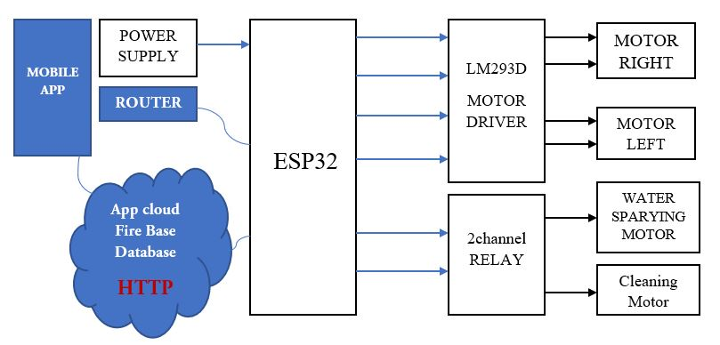

Fig 1: Block diagram of proposed Smart Foor Cleaner

A.ESP32
In our project ESP32 controller is used to control the motor and pumps to drive the car and clean the floor. The spray system of water also controlled by controller. ESP32 is a single 2.4 GHz Wi-Fi-and-Bluetooth combo chip designed with the TSMC ultra-low-power 40 nm technology. It is designed to achieve the best power and RF performance, showing robustness, versatility and reliability in a wide variety of applications and power scenarios.
ESP32 is designed for mobile, wearable electronics, and Internet-of-Things (IoT) applications. It features all the state-of-the-art characteristics of low-power chips, including fine-grained clock gating, multiple power modes, and dynamic power scaling. For instance, in a low-power IoT sensor hub application scenario, ESP32 is woken up periodically and only when a specified condition is detected. Low-duty cycle is used to minimize the amount of energy that the chip expends. The output of the power amplifier is also adjustable, thus contributing to an optimal trade-off between communication range, data rate and power consumption.

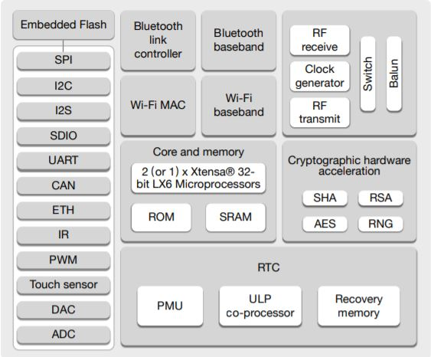
Fig 2: Block Diagram

We have choosen ESP32 due to the specification of that specific microcontroller. From Fig2 The specification of many protocols like SPI,I2C,I2S,SDIO,UART and CAN and many communicative Protocols.
We can code ESP32 through Espressif and Arduino IDE .Espressif is Python based coding Integrated Development Environment .Arduino IDE is a C/C++ based coading Integrated Development Environment. Nowadays C plays a major role in coading sector. So,Arduino IDE is used here.
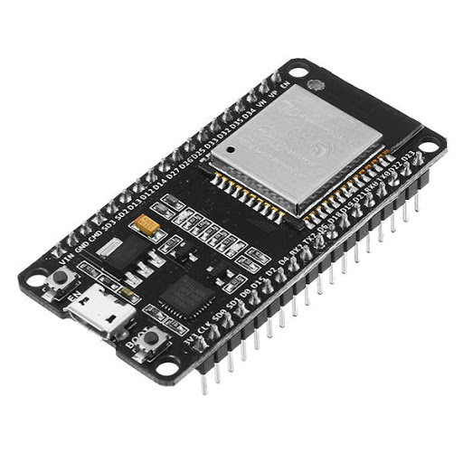
Fig 3: ESP32

B. Sensors
In our project we were designed fully automated floor cleaner system with bluetooth setup. For this automated system we used multiple sensors, one is PIR sensor another one is Ultrasonic sensor. Which are used to sense the object or human near the cleaner path and stop the motors of wheels the after clear the object cleaner moves ahead. PIR and ultrasonic sensors are used in this paper.
A PIR (Passive Infrared) sensor is a motion detector which detects the heat (infrared) emitted naturally by humans and animals. When a person in the field of vision of the sensor moves, the sensor detects a sudden change in infrared energy and the sensor is triggered (activated). They are commonly used in security lighting and alarm systems in an indoor environment. The PIR sensors have a range of approximately 6 meters, depending on conditions.The sensor adjusts to slowly changing conditions that occur normally within the environment, but shows a high-output response when a sudden change takes place.
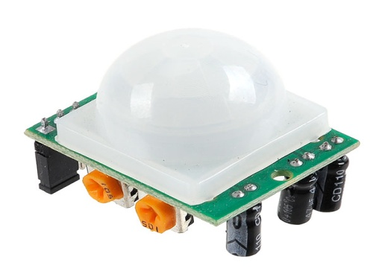
Fig 4: PIR sensor

Ultrasonic sensors are devices that use electrical–mechanical energy transformation to measure distance from the sensor to the target object. Ultrasonic waves are longitudinal mechanical waves which travel as a sequence of compressions and rarefactions along the direction of wave propagation through the medium. Apart from distance measurement, they are also used in ultrasonic material testing (to detect cracks, air bubbles, and other flaws in the products), Object detection, position detection, ultrasonic mouse, etc.
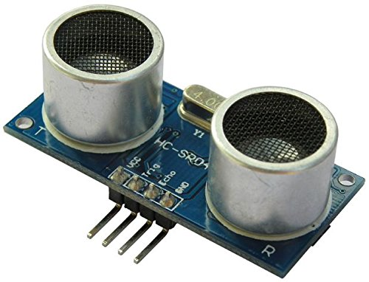
Fig 5: Ultrasonic sensor

C. Geared DC motors
A DC motor is any of a class of rotary electrical machines that converts direct current electrical energy into mechanical energy. The most common types rely on the forces produced by magnetic fields. Nearly all types of DC motors have some internal mechanism, either electromechanical or electronic, to periodically change the direction of current flow in part of the motor. DC motors were the first form of motor widely used, as they could be powered from existing direct-current lighting power distribution systems. A DC motor's speed can be controlled over a wide range, using either a variable supply voltage or by changing the strength of current in its field windings. Small DC motors are used in tools, toys, and appliances. The universal motor can operate on direct current but is a lightweight brushed motor used for portable power tools and appliances. Larger DC motors are currently used in propulsion of electric vehicles, elevator and hoists, and in drives for steel rolling mills. The advent of power electronics has made replacement of DC motors with AC motors possible in many applications.

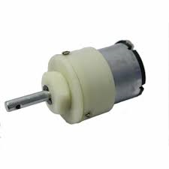
Fig 6: Geared DC motor

- D. Pumps

ESPs are pumps made of dynamic pump stages or centrifugal pump stages. It gives the internal schematic of a single-stage centrifugal pump. It is used to spray the solution and water.
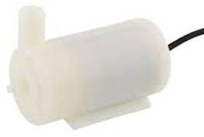
Fig 7: Pump module

- E. Motor Drive
A motor drive, in the field of photography, is a powered film transport mechanism. Historically, film loading, advancing, and rewinding were all manually driven functions. It is used to control the operation of the cleaner wheels

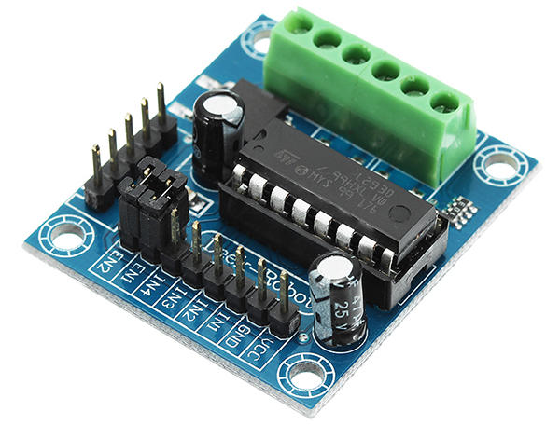
Fig 8: L239DC Motor driver

- F. Lead Acid Battery
An electric battery is a device consisting of one or more electrochemical cells with external connections provided to power electrical devices such as flashlights, smart phones, and electric cars. When a battery is supplying electric power, its positive terminal is the cathode and its negative terminal is the anode.
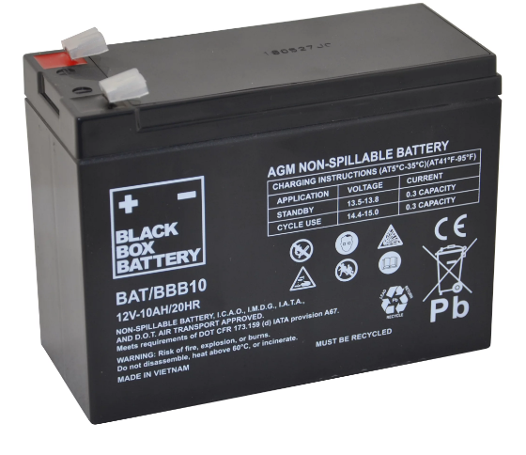
Fig 9: Lead acid battery
- G. Wheels
A wheel is a circular component that is intended to rotate. The wheels are controlled forward and reverse by arduino programming and bluetooth module with the help of driver circuit.
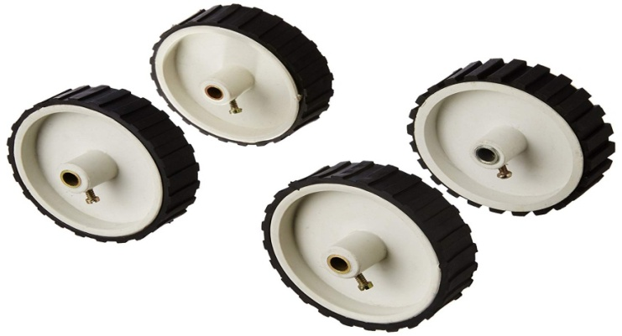
Fig 10: Wheels

A. Embedded Programming
An embedded system is an application that contains at least one programmable computer (typically in the form of a microcontroller, a microprocessor or digital signal processor chip) and which is used by programmer to do particular function.
In this project arudino programming is used to control cleaner and display the outputs. Codes are installed in arduino UNO controller to control the cleaner.

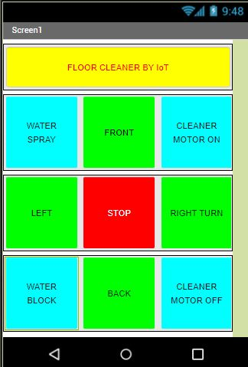

Fig 12: IoT mobile application

B. Code for Smart Floor Cleaner:

#include <WiFi.h>
#include <IOXhop_FirebaseESP32.h>
#define FIREBASE_HOST "https://******.firebaseio.com/" #define FIREBASE_AUTH "XXXXX"
#define WIFI_SSID "XXXXXXXXX"
#define WIFI_PASSWORD "YYYYYYY"
String a = " ";
String b = " ";
String c = " ";
void setup() {
pinMode(13,OUTPUT); //left motors forward
pinMode(12,OUTPUT); //left motors reverse
pinMode(14,OUTPUT); //right motors forward
pinMode(27,OUTPUT); //right motors reverse
pinMode(26,OUTPUT); //water spray
pinMode(25,OUTPUT); //cleaner motor
Serial.begin(9600);
delay(1000);
WiFi.begin(WIFI_SSID, WIFI_PASSWORD);
Serial.print("Connecting to ");
Serial.print(WIFI_SSID);
while (WiFi.status() != WL_CONNECTED) {
Serial.print(".");
delay(500);
}
Serial.println();
Serial.print("Connected to ");
Serial.println(WIFI_SSID);
Serial.print("IP Address is : ");
Serial.println(WiFi.localIP());
Firebase.begin(FIREBASE_HOST, FIREBASE_AUTH);
}

void loop() {
a = Firebase.getString("floorcleaner/variable1");
b = Firebase.getString("floorcleaner/variable2");
c = Firebase.getString("floorcleaner/variable3");
if(a == "F"){
digitalWrite(12,LOW);
digitalWrite(27,LOW);
digitalWrite(13,HIGH);
digitalWrite(14,HIGH);
}
else if(a == "B"){
digitalWrite(13,LOW);
digitalWrite(14,LOW);
digitalWrite(12,HIGH);
digitalWrite(27,HIGH);
}
else if(a == "L"){
digitalWrite(13,LOW);
digitalWrite(14,LOW);
digitalWrite(12,LOW);
digitalWrite(27,HIGH);
}
else if(a == "R"){
digitalWrite(27,LOW);
digitalWrite(14,LOW);
digitalWrite(12,LOW);
digitalWrite(13,HIGH);
}
else if(a == "S"){
digitalWrite(27,LOW);
digitalWrite(14,LOW);
digitalWrite(12,LOW);
digitalWrite(13,LOW);
}
if (b == "on"){
digitalWrite(26,HIGH);
}
else if (b == "off"){
digitalWrite(26,LOW);
}
if (c == "on"){
digitalWrite(25,HIGH);
}
else if (c == "on"){
digitalWrite(25,LOW);
}
}
- FIREBASE DATABASE
  - FIREBASE:
Firebase is a mobile and web application development platform developed by Firebase, Inc. in 2011, then acquired by Google in 2014. [4] As of October 2018, the Firebase platform has 18 products, [5] which are used by 1.5 million apps.
  - FIREBASE CLOUD MESSAGING:
Formerly known as Google Cloud Messaging (GCM), Firebase Cloud Messaging (FCM) is a cross-platform solution for messages and notifications for Android, iOS, and web applications, which as of 2016 can be used at no cost.
  - FIREBASE REALTIME DATABASE:
Firebase provides a real-time database and back-end as a service. The service provides application developers an API that allows application data to be synchronized across clients and stored on Firebase's cloud. [25][26] The company provides client libraries that enable integration with Android, iOS, JavaScript, Java, Objective-C, Swift and Node.js applications. The database is also accessible through a REST API and bindings for several JavaScript frameworks such as AngularJS, React, Ember.js and Backbone.js. [27] The REST API uses the Server-Sent Events protocol, which is an API for creating HTTP connections for receiving push notifications from a server. Developers using the real time database can secure their data by using the company's server-side-enforced security rules. [28]
  - CLOUD FIRESTORE
On January 31, 2019, Cloud Firestore was officially brought out of beta, making it an official product of the Firebase lineup. [29] It is the successor to Firebase's original databasing system, Real-time Database, and allows for nested documents and fields rather than the tree-view provided in the Real-time Database.
  - FIREBASE STORAGE
Firebase Storage provides secure file uploads and downloads for Firebase apps, regardless of network quality, to be used for storing images, audio, video, or other user generated content. It is backed by Google Cloud Storage.
  - FIREBASE HOSTING
Firebase Hosting is a static and dynamic web hosting service that launched on May 13, 2014. It supports hosting static files such as CSS, HTML, JavaScript and other files, as well as support through Cloud Functions. [31] The service delivers files over a content delivery network (CDN) through HTTP Secure (HTTPS) and Secure Sockets Layer encryption (SSL). Firebase partners with Fastly, a CDN, to provide the CDN backing Firebase Hosting. The company states that Firebase Hosting grew out of customer requests; developers were using Firebase for its real-time database but needed a place to host their content.
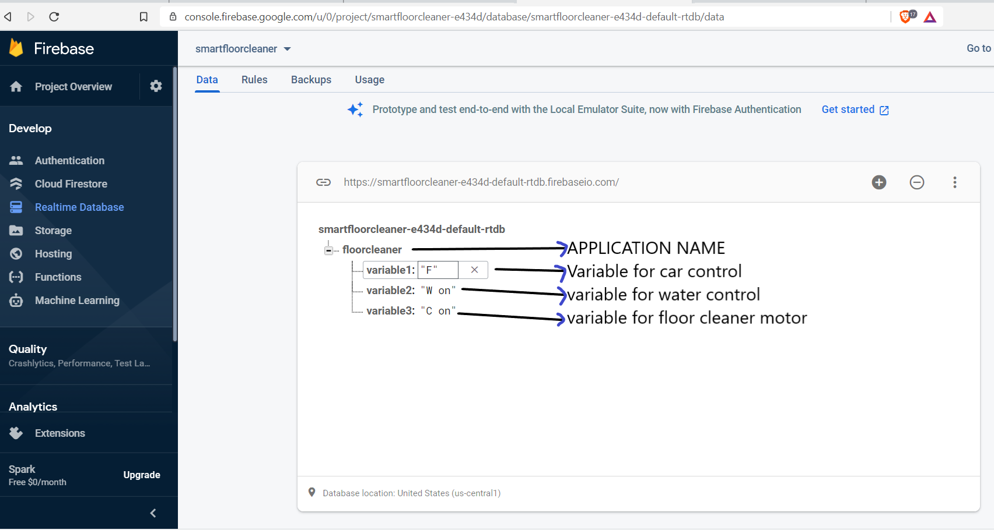
Fig 13. Firebase Realtime DataBase.

- PROTOTYPE MODULE OF AEMS
Floor Cleaner Module
In this system we are design smart floor cleaning robot that allows cleaning the floor by giving instructions to the robot. This robot makes floor cleaning process easy and fast utilizing a wireless robotic cleaning system. This wireless system consists of a transmitter application that runs on an android mobile app which allows the robot to follow commands given by the user through the transmitter app. The proposed robot consists of ESP32 controller which has fourteen digital input/output pins, robotic arm with cleaning pad for efficient cleaning. The ESP32, on receiving the commands from android device through HTTP protocols, decodes the given commands and controls the motors to achieve the desired path and direction. It can control by mobile using Wi-Fi module and semi automatic cleaning control. First this module can do the dry cleaning and the wet cleaning process. It reduces the cleaning time to the half. This proposed system is a portable low cost module and simple control key used to make this system user friendly.
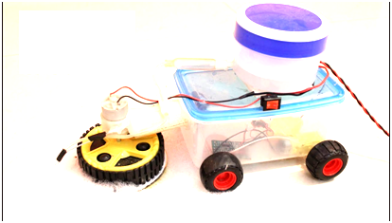

Fig 14. Prototype module of SFC

VI. CONCLUSION

Thus the smart floor cleaner system is implemented with two modules one is spray and cleaner module and automatic driver module. This research facilitates efficient floor cleaning. Since in project the floor cleaner is incorporated with different devices like DC motor, L239D etc., so it will be easy to handle it also saves time and will work automatically for cleaning purpose at homes and offices. With simple program, the cleaner will be able to cover large floor areas as well as find its way into and out of small corners. As the cleaner traverses the room, the sweeper installed in it will manage to pick up a significant amount of dirt. Manual Sweeping might not be that effective as it will not be picking up everything in as it is not in sight but using the automatic floor cleaner it can be done easily.

REFERENCES

[1] Andrew Ziegler, Christopher John Morse, Duane L. Gilbert, Jr., Andrew Jones, “Autonomous surface cleaning robot for dry cleaning,” U.S. Patent 8782848 B2, July 22, 2014.
[2] Andrew Ziegler, Duane Gilbert, Christopher John Morse, Scott Pratt, Paul Sandin, Nancy Dussault, Andrew Jones, “Autonomous surface cleaning robot for wet and dry cleaning,” U.S. Patent 7389156 B2, June 17, 2008.
[3] Buck, 'The Best Robot Vacuums of 2015 | Top Ten Reviews', TopTenREVIEWS, 2014. [Online]. Available: http://robot-vacuumreview.toptenreviews.com/.
[4] Dyson.com, 'Latest Dyson Vacuum Cleaner Technology | Dyson.com', 2015.[Online]. Available: http://www.dyson.com/vacuum-cleaners.aspx.
[5] Dyson 360 Eyeâ„¢ robot, 'Dyson 360 Eyeâ„¢ robot', 2015.[Online].Available: https://www.dyson360eye.com/.
[6] Harvey Koselka, Bret A. Wallach, David Gollaher,“Autonomous floor mopping apparatus,” U.S. Patent 6741054 B2, May 25, 2004.
[7] IEEE Standard for User Interface Elements in Power Control of Electronic Devices employed in Office/Consumer Environments, IEEE Standard 1621,2004(R2009).
[8] Irobot.com, 'iRobot Corporation: We Are The Robot Company', 2015. [Online]. Available: http://www.irobot.com/.
[9] Joseph L. Jones, Newton E. Mack, David M. Nugent, Paul E. Sandin, “Autonomous floor-cleaning robot,” U.S. Patent 6883201 B2, April 6, 2005.
[10] Michael Dooley, James Philip Case, and Nikolai Romanov,“System and method for autonomous mopping of a floor surface,” U.S. Patent 8 892 251 B1, November 18, 2014.
[11] Neato, 'Neato Robotics | Smartest, Most Powerful, Best Robot Vacuum', 2015.[Online]. Available: http://www.neatorobotics.com/.
[12] Yusuf AbdullahiBadamasi, The Working Principle Of An Arduino, Electronics, Computer and Computation (ICECCO), 2014 11th International Conference on 29 Sept.-1 Oct. 2014.

